**Name: Soumitri Chattopadhyay**

**Roll: 001911001083**

**Department: Information Technology**

**Year: UG-III (5th Semester)**

**Subject: Artificial Intelligence Laboratory**

**Assignment 6: Please do the following as per the Prolog Assignment Explanation given below.**

**Date: 04.11.2021**

--------------------------------------------------------------------------------------------------------------------------------

**Assignment Details:**

1. Please run the following attached prolog files

2. Find some of the answers of the predicate sibling and full_siblings where it is true and false. Attach some full screenshots of those queries and answers.

3. Use uncle and aunt predicate on some values in query processing and relate on the knowledge base and justify the answer generated by prolog in a document. Use the full screenshots of the answer in preparation for the documentation.

--------------------------------------------------------------------------------------------------------------------------------

**Results and Discussion:**

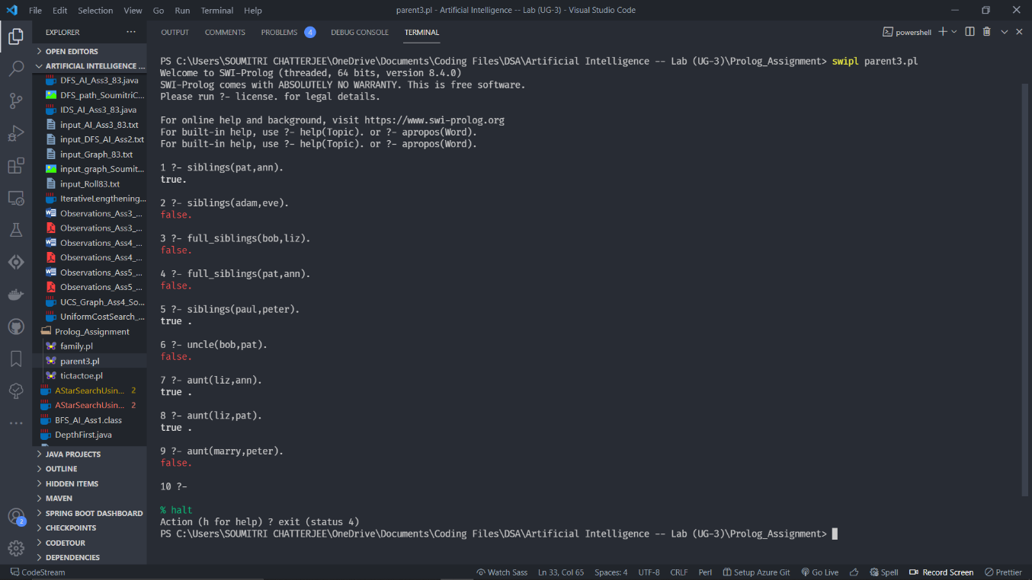

The outputs have been provided in the above given terminal screenshot. The following section explains each of the queries and their outputs:

1. “pat” and “ann” both have the same parent (i.e. “bob”), thereby satisfying the condition “atleast one common parent”. Thus, the query outputs TRUE.
2. “adam” and “eve” have no parents specified and hence the condition of having “atleast one common parent” is NOT satisfied. Thus, the query outputs FALSE.
3. “bob” has parents (tom, pam) whereas “liz” has a single parent (tom), and so the condition of *full_sibling* i.e. having “both parents common” is NOT satisfied. Thus, the query outputs FALSE.
4. “pat” and “ann” both have the same parent (i.e. bob), but the fact that they have a single parent nullifies the condition of *full_sibling* i.e. having “both parents common”. Thus, the query outputs FALSE. Note that the given pair satisfies for *siblings* condition (“atleast one common parent”).
5. “paul” and “peter” both have a common parent i.e. “adam”, thereby satisfying the condition of being *siblings* (“atleast one common parent”). Thus, the query outputs TRUE.
6. According to the given relations, “bob” is the parent of “pat”, and hence there exists no $P$ such that $siblings("bob",P)=True \& parent(P,"pat")=True.$ Thus, the query outputs FALSE.
7. From the relations, we get “liz” has a sibling “bob” (since they have a common parent “tom”), while “bob” has a child “ann”. So, $for Q="bob"$ we get the relation $siblings("liz",Q)=True \& parent(Q,"ann")=True$. Further, “liz” is a *woman* as given in the relations. Thus, the query returns TRUE.
8. It is given that “liz” has a sibling “bob” (since they have a common parent “tom”), while “bob” has a child “pat”. So, $for R="bob"$ we get the relation $siblings("liz",R)=True \& parent(R,"pat")=True$. Further, “liz” is a *woman* as given in the relations. Thus, the query returns TRUE.
9. “marry” and “peter” have no relation between them and thus there exist **NO such $S$** such that $siblings("marry", S) = True and parent(S, "peter")=True.$ Thus, the condition for $aunt("marry", "peter")$ is NOT satisfied. Thus, the query returns FALSE.